**/* 2, 3, 4 */**

**KPI:** GA

FREQUENCY: NRT (Run every 2 Hours)

TARGET TABLE: SALES_DIGI_ECO_GA_KPI_DWH

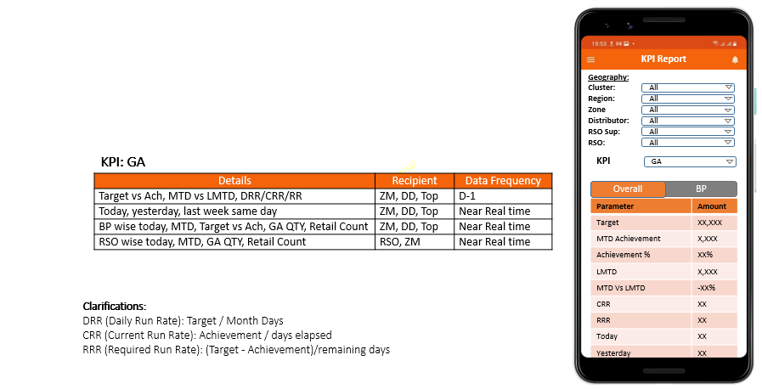

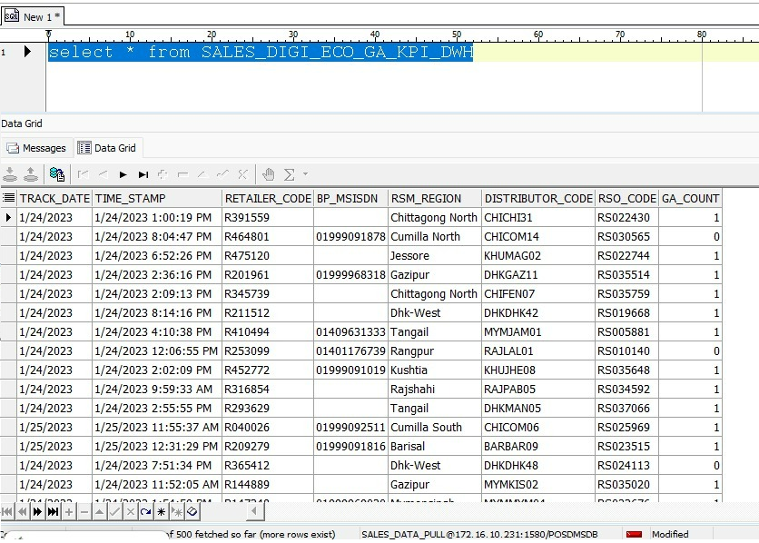

**Report Date:** 24-Jan-2023

**Monthly Target:** 15,000

|  |  |  |  |
| --- | --- | --- | --- |
| **Parameter** | **Overall Amount** |  | **Understanding of Logic** |
| Target | 10,000 | D-1 | Cumulative Target of Month |
| MTD Achievement | 2,000 | D-1 | Cumulative Achievement of MTD |
| Achievement % | 20% | D-1 | (Achievement/ Target)*100 |
| LMTD | 1,500 | D-1 | Cumulative Achievement of LMTD |
| MTD Vs LMTD | ((2,000-1,800)/1,800)*100= 10% | D-1 | ((MTD-LMTD)/LMTD)*100 |
| DRR | (15,000 / 31) = 483.87 | D-1 | Target / Month Days |
| CRR | (2,000/23) = 86.96 | D-1 | Achievement / days elapsed |
| RR | (15000-2000)/8= 333.33 | D-1 | (Target - Achievement)/remaining days |
| Today | 300 | NTR | Cumulative Achievement of todays’ till time |
| Yesterday | 200 | NTR | Cumulative Achievement of yesterday (Full day) |
| Last week same day | 280 | NTR | Cumulative Achievement of last week same day (Full day) |

**Note:**

* MTD vs LMTD decimal value must be Rounded up to next integer value.
* For DRR, CRR, RR decimal value must Rounded up to next integer value.

**Question:**

1. MTD Vs LMTD: If the equation is negative value, what should be represented in App? Ans: negative sign (-) with red color.

**Report Date:** 24-Jan-2023

**Monthly Target:** 1,200

|  |  |  |  |
| --- | --- | --- | --- |
| **Parameter** | **BP wise Amount** |  | **Understanding of Logic** |
| Target | 500 | NTR | BP wise cumulative Target of Month |
| MTD Achievement | 400 | NTR | BP wise cumulative Achievement of MTD |
| Achievement % | 33.33 | NTR | (Achievement/ Target)*100 |
| GA Count Today’s | 300 | NTR | GA Activation Quantity of Today’s till time |
| Retail Count MTD | 50 | NTR | Retail Count of MTD (unique retail with GA) |
| Retail Count Today |  | NTR | Retail Count of Today (unique retail with GA) |

**Question:**

1. GA QTY – Does it mean **GA QTY** of today or MTD? Ans: Both
2. Retail Count - Does it mean **Retail Count** of today or MTD? Ans: Both
3. What does it mean BP wise Today? Ans: A Different Tab where BP wise information will show.
4. BP wise Target Vs Achievement: What is the source of BP wise target?

* Need to build capability to upload BP target. Excel Upload file format: (BP MSISDN, Target QTY)

**Report Date:** 24-Jan-2023

**Monthly Target:** 1,200

|  |  |  |  |
| --- | --- | --- | --- |
| **Parameter** | **RSO wise Amount** |  | **Understanding of Logic** |
| Target | 500 | NTR | RSO wise cumulative Target of Month |
| MTD Achievement | 400 | NTR | RSO wise cumulative Achievement of MTD |
| Achievement % | 33.33 | NTR | (Achievement/ Target)*100 |
| GA QTY (Today) |  | NTR | GA Activation Quantity of Today’s till time |
| GA QTY MTD | 300 | NTR | GA Activation Quantity of MTD |
| Retail Count Today | 50 | NTR | Retail Count of Today (unique retail with GA) |
| Retail Count MTD |  | NTR | Retail Count of MTD (unique retail with GA) |

**Question:**

1. GA QTY – Does it mean **GA QTY** of today or MTD? Ans: Both
2. Retail Count - Does it mean **Retail Count** of today or MTD? Ans: Both
3. What does it mean RSO wise Today?

Ans: A Different Tab where RSO wise information will show.

**/* 5 6 7*/  
KPI: All Bundle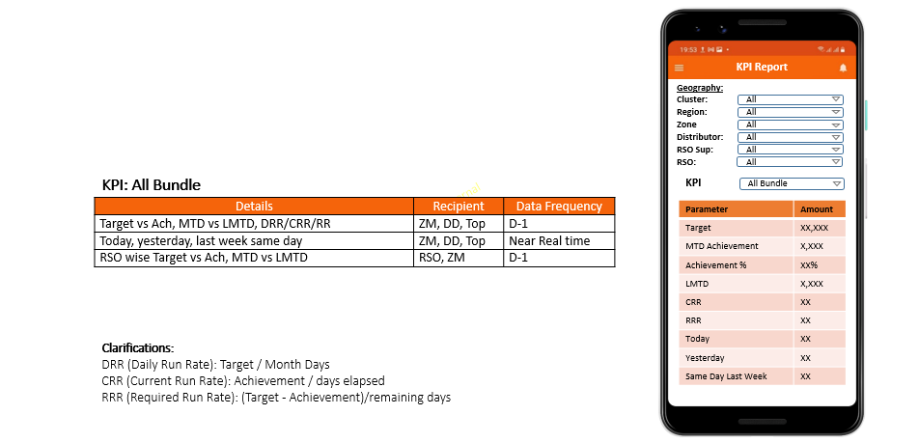 Report Date:** 24-Jan-2023

**Monthly Target:** 15,000

|  |  |  |  |
| --- | --- | --- | --- |
| **Parameter** | **Amount** |  | **Understanding of Logic** |
| Target | 10,000 | D-1 | Cumulative Target of Month |
| MTD Achievement | 2,000 | D-1 | Cumulative Achievement of MTD |
| Achievement % | 20% | D-1 | (Achievement/ Target)*100 |
| LMTD | 1,500 | D-1 | Cumulative Achievement of LMTD |
| MTD Vs LMTD | ((2,000-1,800)/1,800)*100= 10% | D-1 | ((MTD-LMTD)/LMTD)*100 |
| DRR | (15,000 / 31) = 483.87 | D-1 | Target / Month Days |
| CRR | (2,000/23) = 86.96 | D-1 | Achievement / days elapsed |
| RR | (15000-2000)/8= 333.33 | D-1 | (Target - Achievement)/remaining days |
| Today | 300 | NTR | Cumulative Achievement of todays’ till time |
| Yesterday | 200 | NTR | Cumulative Achievement of yesterday (Full day) |
| Last week same day | 280 | NTR | Cumulative Achievement of last week same day (Full day) |

**Note: We do not get data source for near real time.**

**Note:**

* MTD vs LMTD decimal value should display 2 decimal value.
* For DRR, CRR, RR decimal value should display 2 decimal value.

**/* 8 9 10 11 */**

**KPI: Data**

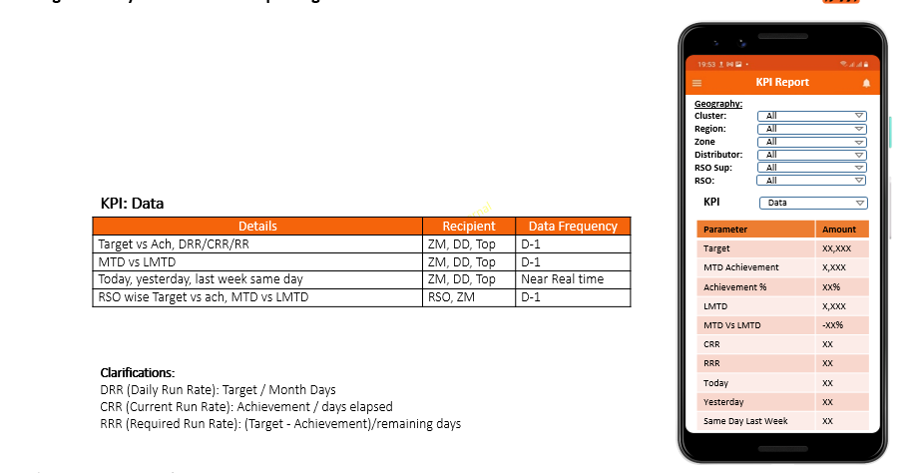

**Report Date:** 24-Jan-2023

**Monthly Target:** 1,200

|  |  |  |  |
| --- | --- | --- | --- |
| **Parameter** | **Amount** |  | **Understanding of Logic** |
| Target | 10,000 | D-1 | Cumulative Target of Month |
| MTD Achievement | 2,000 | D-1 | Cumulative Achievement of MTD |
| Achievement % | 20% | D-1 | (Achievement/ Target)*100 |
| LMTD | 1,500 | D-1 | Cumulative Achievement of LMTD |
| MTD Vs LMTD | ((2,000-1,800)/1,800)*100= 10% | D-1 | ((MTD-LMTD)/LMTD)*100 |
| DRR | (15,000 / 31) = 483.87 | D-1 | Target / Month Days |
| CRR | (2,000/23) = 86.96 | D-1 | Achievement / days elapsed |
| RR | (15000-2000)/8= 333.33 | D-1 | (Target - Achievement)/remaining days |
| Today | 300 | NTR | Cumulative Achievement of todays’ till time |
| Yesterday | 200 | NTR | Cumulative Achievement of yesterday (Full day) |
| Last week same day | 280 | NTR | Cumulative Achievement of last week same day (Full day) |

**Note: We do not get data source for near real time.**

**Note:**

* MTD vs LMTD decimal value should display 2 decimal value.
* For DRR, CRR, RR decimal value should display 2 decimal value.

**/* 12 13 */**

**KPI:** EV

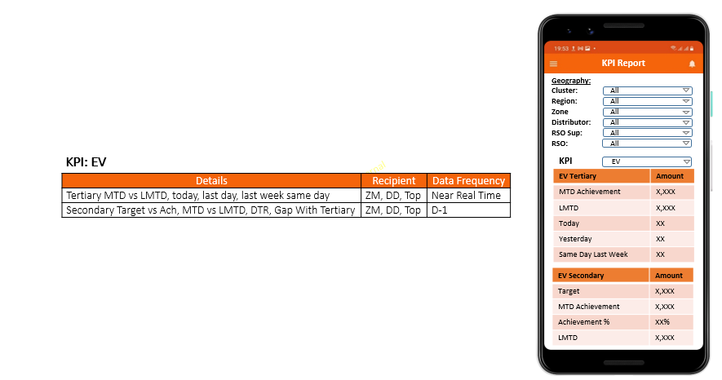

**EV Tertiary:**

|  |  |  |  |
| --- | --- | --- | --- |
| **Parameter** | **Amount** |  | **Understanding of Logic** |
| MTD Achievement | 2,000 | NTR | Cumulative Achievement of MTD |
| LMTD | 1,500 | NTR | Cumulative Achievement of LMTD |
| Today | 300 | NTR | Cumulative Achievement of todays’ till time |
| Yesterday | 200 | NTR | Cumulative Achievement of yesterday (Full day) |
| Last week same day | 280 | NTR | Cumulative Achievement of last week same day (Full day) |

**EV Secondary:**

|  |  |  |  |
| --- | --- | --- | --- |
| **Parameter** | **Amount** |  | **Understanding of Logic** |
| Target | 15,000 | D-1 | Cumulative Target of Month |
| MTD Achievement | 2,000 | D-1 | Cumulative Achievement of MTD |
| Achievement % | 20% | D-1 | (Achievement/ Target)*100 |
| LMTD | 1,500 | D-1 | Cumulative Achievement of LMTD |
| DTR | 200 | D-1 | O2C data. |
| GAP with Tertiary | 280 | D-1 | Gap between (C2C / C2S – C2C)/100 |

**Note: We do not get data source for near real time.**

**Question:**

1. What is DTR? Ans: O2C data ??

2. What is the data source of GAP with Tertiary? Gap between (C2C / C2S – C2C)/100

**/* 14 15 */**

**KPI:** SC

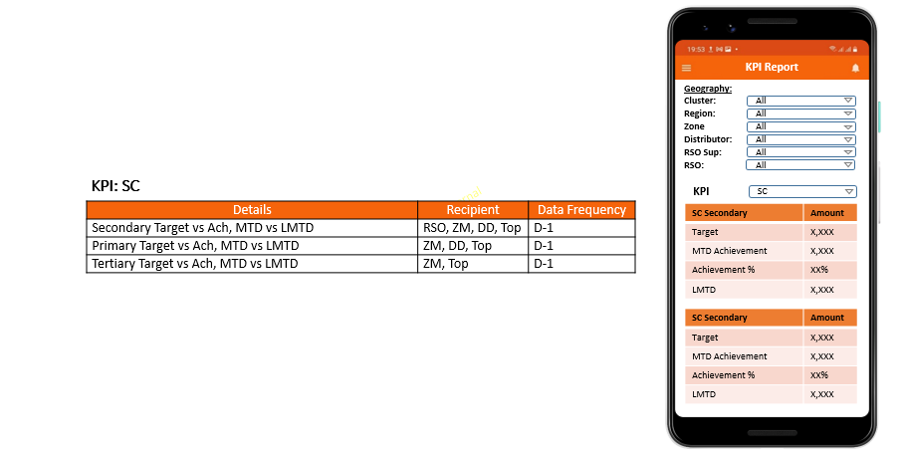

**SC Secondary:**

|  |  |  |  |
| --- | --- | --- | --- |
| **Parameter** | **Amount** |  | **Understanding of Logic** |
| Target | 15,000 | D-1 | Cumulative Target of Month |
| MTD Achievement | 2,000 | D-1 | Cumulative Achievement of MTD |
| Achievement % | 20% | D-1 | (Achievement/ Target)*100 |
| LMTD | 1,500 | D-1 | Cumulative Achievement of LMTD |

**SC Primary:**

|  |  |  |  |
| --- | --- | --- | --- |
| **Parameter** | **Amount** |  | **Understanding of Logic** |
| Target | 15,000 | D-1 | Cumulative Target of Month |
| MTD Achievement | 2,000 | D-1 | Cumulative Achievement of MTD |
| Achievement % | 20% | D-1 | (Achievement/ Target)*100 |
| LMTD | 1,500 | D-1 | Cumulative Achievement of LMTD |

**SC Tertiary:**

|  |  |  |  |
| --- | --- | --- | --- |
| **Parameter** | **Amount** |  | **Understanding of Logic** |
| Target | 15,000 | D-1 | Cumulative Target of MTD |
| MTD Achievement | 2,000 | D-1 | Cumulative Achievement of MTD |
| Achievement % | 20% | D-1 | (Achievement/ Target)*100 |
| LMTD | 1,500 | D-1 | Cumulative Achievement of LMTD |

**Note:** Target will be uploaded from Web/App End (Need to develop Capability)

Target Upload File Format: ---- (RSO, DD, Target Amount)

**/* 16, 17, 18, 19 */**

**KPI:** LSO, DLSO, SSO, DSSO

FREQUENCY: D-1

TARGET TABLE: SALES_DIGI_ECO_LSO_KPI_DWH

TARGET TABLE: SALES_DIGI_ECO_DLSO_KPI_DWH

TARGET TABLE: SALES_DIGI_ECO_SSO_KPI_DWH

TARGET TABLE: SALES_DIGI_ECO_DSSO_KPI_DWH

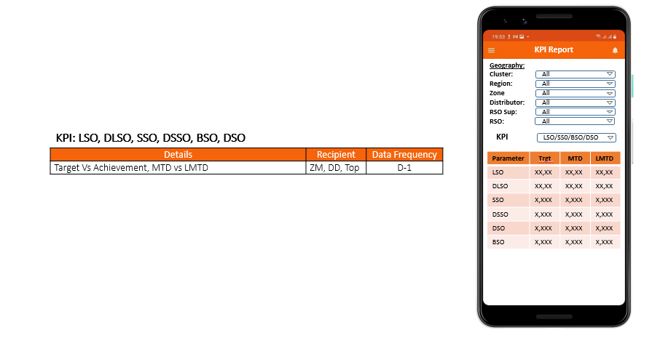

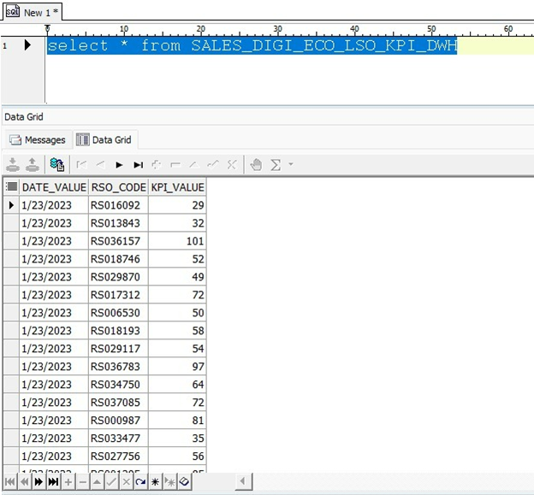

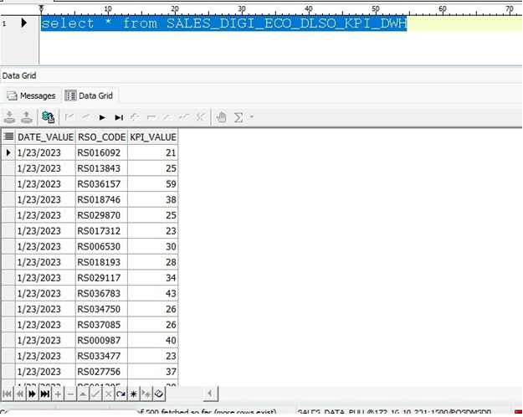

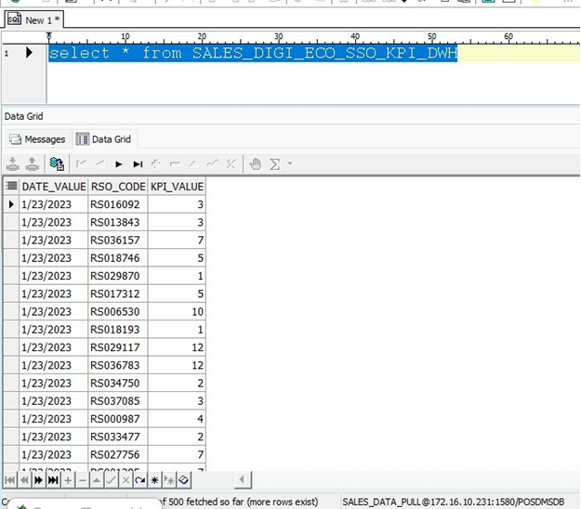

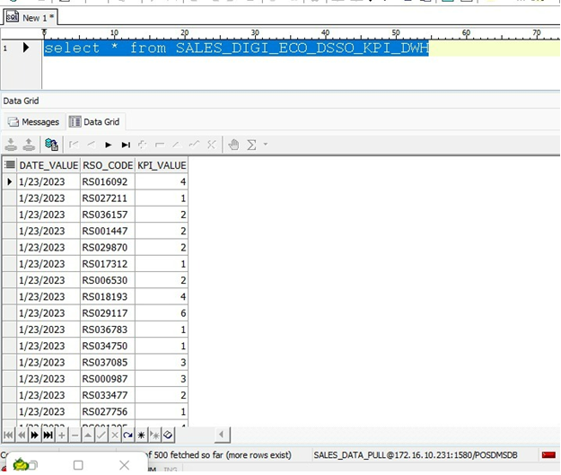

|  |  |  |  |  |  |
| --- | --- | --- | --- | --- | --- |
| **Parameter** |  | **Target** | **MTD** | **MTD%** | **LMTD** |
| LSO | D-1 | 10000 | 7000 |  | 6000 |
| DLSO | D-1 | 10000 | 8000 |  | 8500 |
| SSO | D-1 | 10000 | 5000 |  | 5500 |
| DSSO | D-1 | 10000 | 6000 |  | 5700 |

**Question:**

1. What is the source of Target data of LSO, DLSO, SSO, DSSO?

**Note:** Target will be uploaded from Web/App End (Need to develop Capability)

Target Upload File Format: ---- (RSO, DD, Target Amount)

* MTD: Total Amount and Percentage (%)

**/*20 21 */**

**KPI:** DSO, BSO

|  |  |  |  |  |  |
| --- | --- | --- | --- | --- | --- |
| **Parameter** |  | **Target** | **MTD** | **MTD%** | **LMTD** |
| BSO | D-1 | 10000 | 5000 |  | 5500 |
| DSO | D-1 | 10000 | 6000 |  | 5700 |

**Note:** Target will be uploaded from Web/App End (Need to develop Capability)

Target Upload File Format: ---- (RSO, DD, Target Amount)

**/* 22, 23 */**

**KPI:** Retail SCR

FREQUENCY: D-1

TARGET TABLE: SALES_DIGI_ECO_RETAIL_SCR_KPI_DWH

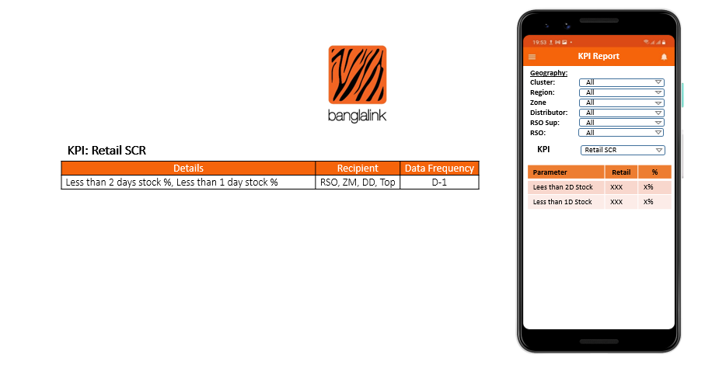

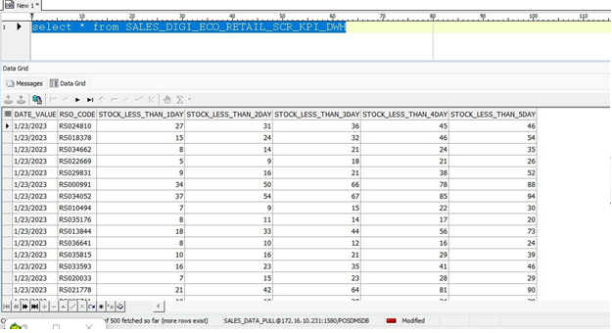

|  |  |  |
| --- | --- | --- |
| **Parameter** | **Retail** | **%** |
| Less Than 2D Stock | 100 | 20% |
| Less Than 1D Stock | 150 | 70% |

Less Than 2D/1D Retail Count: count of retail with available balance below 2D/1D average sales

% = (Less than 2D/1D retail count/ total retail) * 100

**/*           24           */**

**KPI:** M1/M2 Decay

FREQUENCY: MONTHLY (5TH)

TARGET TABLE: SALES_DIGI_ECO_DECAY_KPI_DWH

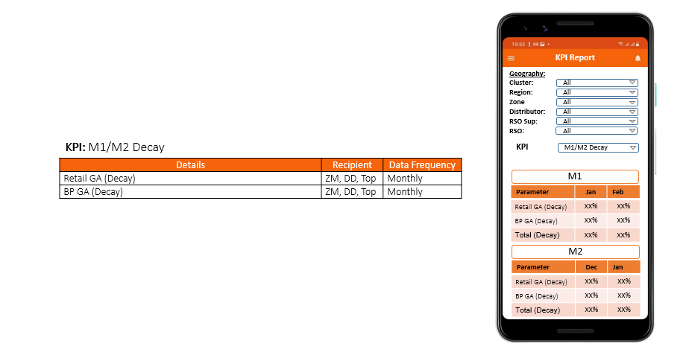

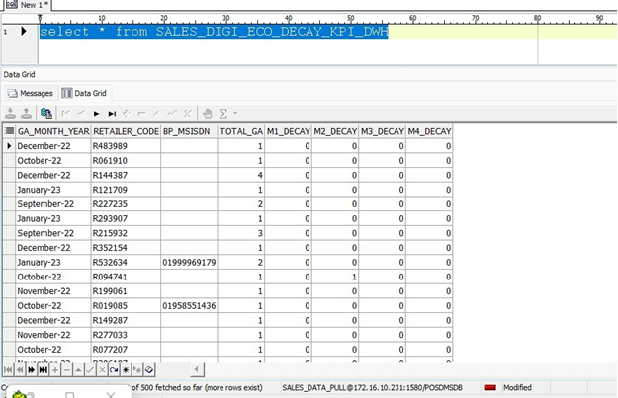

**M1 Decay:**

|  |  |  |
| --- | --- | --- |
| **Parameter** | **Jan (Previous Month)%** | **Feb (Current Month)%** |
| Retail GA (Decay) |  |  |
| BP GA (Decay) |  |  |
| Total GA (Decay) |  |  |

**M2 Decay:**

|  |  |  |
| --- | --- | --- |
| **Parameter** | **Dec (Previous Month 2)%** | **Jan (Previous Month 1)%** |
| Retail GA (Decay) |  |  |
| BP GA (Decay) |  |  |
| Total GA (Decay) |  |  |

**Note:**

Calculation: (Decay M1 /Total GA of M1) *100

Calculation: (Decay M2 /Total GA of M2) *100

**/*           25 26           */**

**KPI:** App Utilization

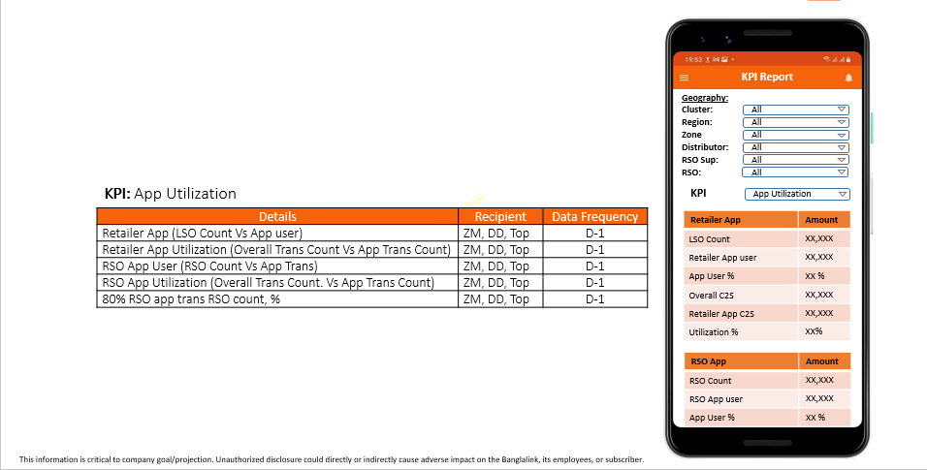

|  |  |
| --- | --- |
| **Retailer App** | **Amount** |
| LSO Count | Cumulative count of Load Selling outlet |
| Retailer App user | Cumulative count of App user |
| App user % | (App user / Total Retailer)* 100 |
| Overall C2S | Cumulative count of C2S |
| Retailer App C2S | Cumulative count of C2S from Retailer App |
| Utilization % | (App C2S count / Overall Count) * 100 |

|  |  |
| --- | --- |
| **RSO App** | **Amount** |
| RSO Count | Cumulative count of RSO Count |
| RSO App user | Cumulative count of App user |
| App user % | (App user / Total RSO)* 100 |
| Overall C2C count | Cumulative count of C2C |
| RSO App C2C count | Cumulative count of C2C from RSO App |
| Utilization % | (App C2C count / Overall Count) * 100 |
| 80% RSO app trans RSO count | 200 RSO utilization more than equal 80% (only Itopup) |

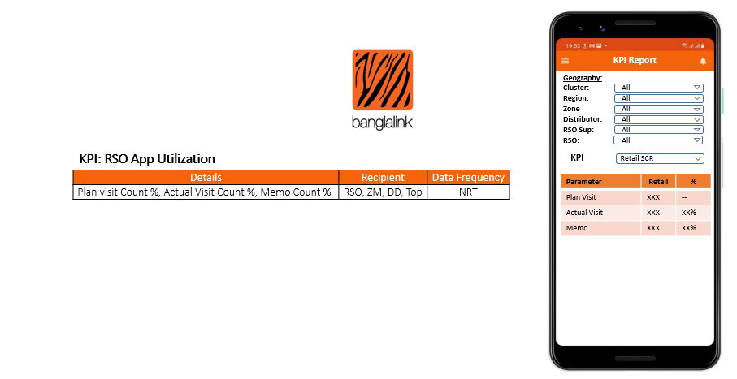

Plan Visit = Retail Count of D-1

Actual visit = Visited Retail Count of D-1

Actual Visit % = (Actual Visit count/ Plan Visit count) * 100

Memo = Memo Count of D-1

Memo % = (MEMO count/ Actual Visit count) * 100

**/*           28           */**

**KPI:** Deno

FREQUENCY: NRT (EVERY 30 MINUTES)

TARGET TABLE: SALES_DIGI_ECO_NRT_DENO_KPI_DWH

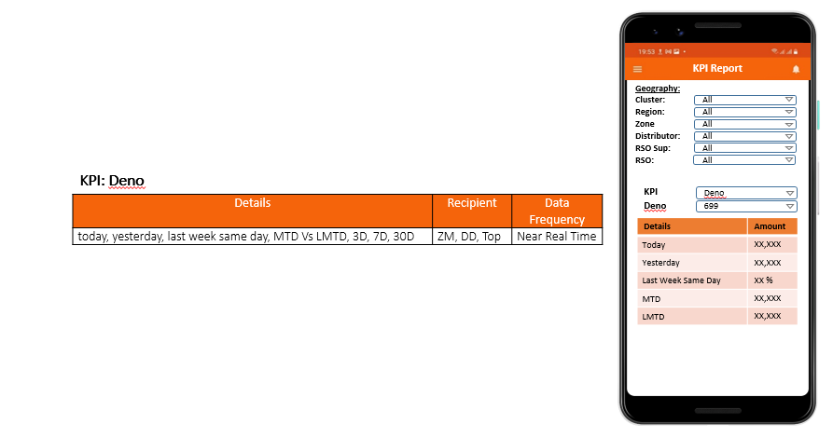

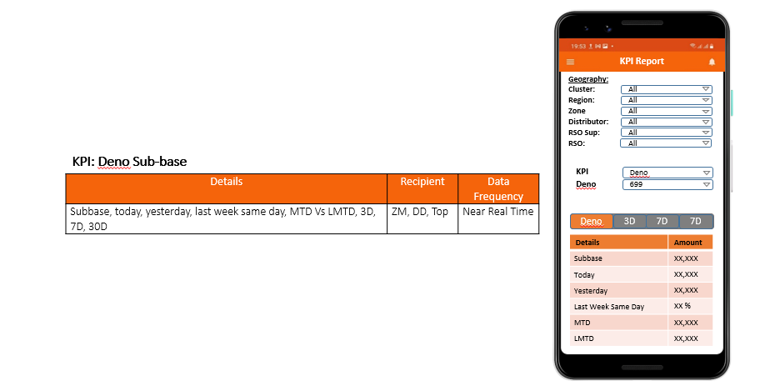

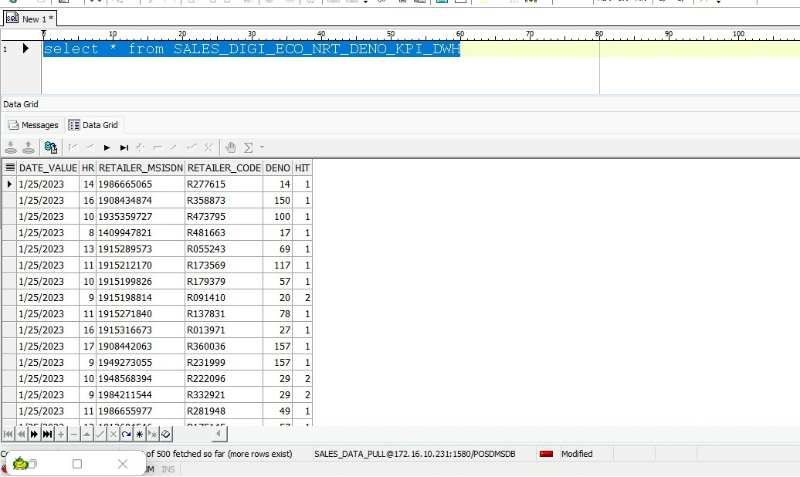

Question:

1. What does subbase mean? Example: 399 TK package and how many customers purchased that package (Hero Deno as Popular package (DMS) as type).

**Note:** clarification required on data mapping with App.

Amount calculation: HIT count * Deno (50*399)

**/* 29 */**

**KPI:** Site

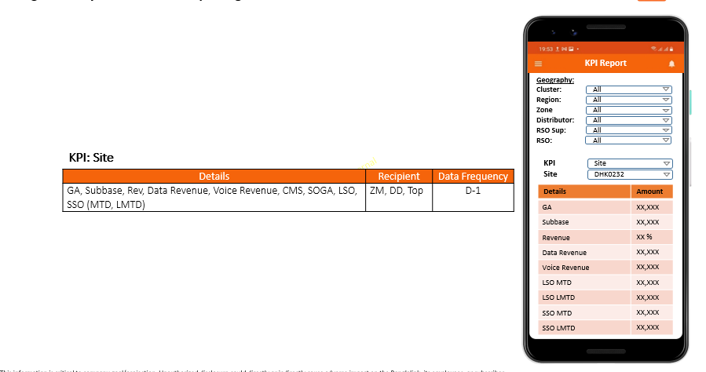

|  |  |
| --- | --- |
| Detail | Amount |
| GA |  |
| Subbase |  |
| Revenue |  |
| Data Revenue |  |
| Voice Revenue |  |
| CSM |  |
| SOGA |  |
| LSO MTD |  |
| LSO LMTD |  |
| SSO MTD |  |
| SSO LMTD |  |

**/* 30 */**

**KPI: All,** LUS, SRAN, Rest (add drop down list under KPI)

**Note:** Mobile Application UI sample is not provided.

**Same Ware Framing as given above for KPI: Site**